
Documentation
(Editor)

Contents
Setting up 3
Cellular Automata 4
Terrain 5
Blocks 7
Noise Layers 8

Thank you for purchasing GenX 3D framework!
This documentation will guide you through everything you need to know to start creating your own procedural worlds.

Setting up
To visually edit generation parameters, you need to add the ‘CellularAutomata’script or ‘VoxelTerrain’script to any game object in your scene. You don't have to do it if you plan to utilize lower level functions and create maps yourself, or if you'll only work with static methods.
Try not to have more than one of each scripts in your scene so you can access them with a singleton.

Cellular Automata
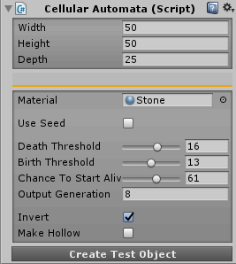
Cellular Automata script in editor
Output map is generated by applying a set of rules to a random initial map.
In a map, every cell can be either dead or alive (0 or 1, false or true). These are the rules:
- If a living cell has less living neighbours than ‘Death Threshold’ – it dies.
- If a dead cell has more living neighbours than ‘Birth Threshold’ – it becomes alive.
By repeating this simulation over and over we can get different shapes and structures, depending on the input values.

Let's go through the parameters.
- Width
- Height
- Depth
Size of the structure.
- Mesh Material
- Use Seed
Should generation be predetermined by a seed?
- Death Threshold and Birth Threshold:
See above.
- Chance to Start Alive
Chance a cell of the initial map will be alive. Determines the fullness of the map.
- Output Generation
Number of times a set of rules is applied.
- Invert
Should the final map be inverted?
- Make Hollow
Make the final map empty on the inside?

Terrain
Generate and dynamically load endless terrain, create block types, set generation parameters for each block type and more.
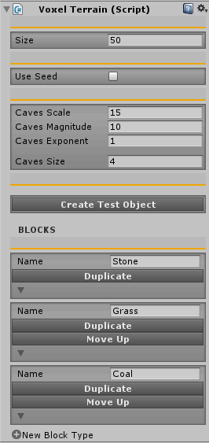

- Size
Size of the structure in blocks
- Use Seed
Should generation be predetermined by a seed?

Cave Settings:
- Caves Scale
Scale of noise that is used to generate caves.
- Cave Magnitude
Magnitude of noise that is used to generate caves.
- Cave Exponent
- Cave Size

Blocks
To add new block type, click
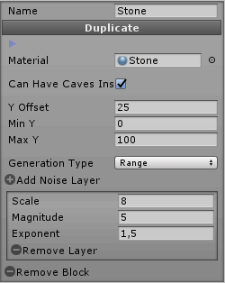
- Name
- Can Have Caves Inside
- Max and Min Y
Max and Min height at which this block type can spawn.
- Generation Type:
- Group - 3D Perlin noise based generation.
- Group Size –size of the groups.
- Random - every block has a random chance of being this type
- Spawn Chance –chance that a block will be of this type.
- Range Y - 2D Perlin noise based generation;
- Y Offset - global height offset of this block type.

Noise Layers
Layers of noise that define terrain generation.
To add a layer, click

- Scale:
Scale of this noise layer. Basically, the frequency of the noise.
- Magnitude:
Magnitude of this noise layer. Larger value gives more difference between the highest and lowest possible point.
- Exponent.

